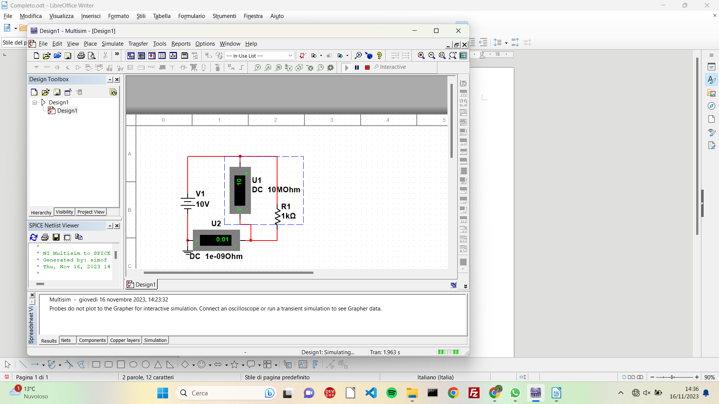
Esercizio 1

V=10V
R1=1k Ω
i=V/R1=10V/1k Ω=0,01 A
V1=i*R1=0,01A*1k Ω=10 V

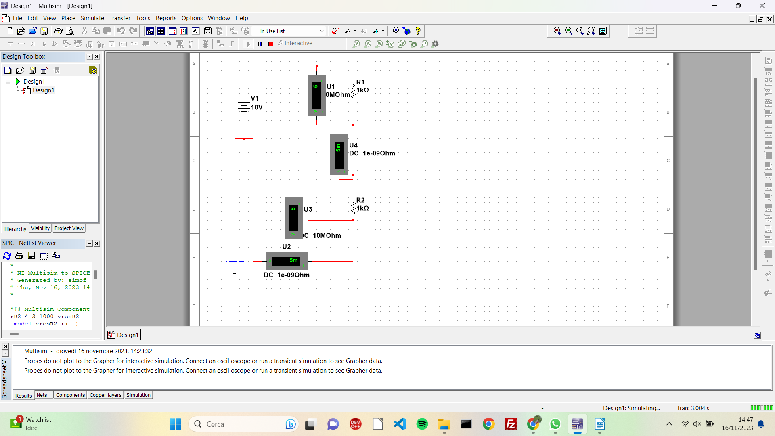
Es 2
V=10V
R1=1kΩ
R2=1kΩ
i1=i2=V/Req=10V/(1k Ω+1k Ω)=5mA
V1=i1*R1=5mA*1kΩ=5V
V2=i2*R2=5mA*1kΩ =5V

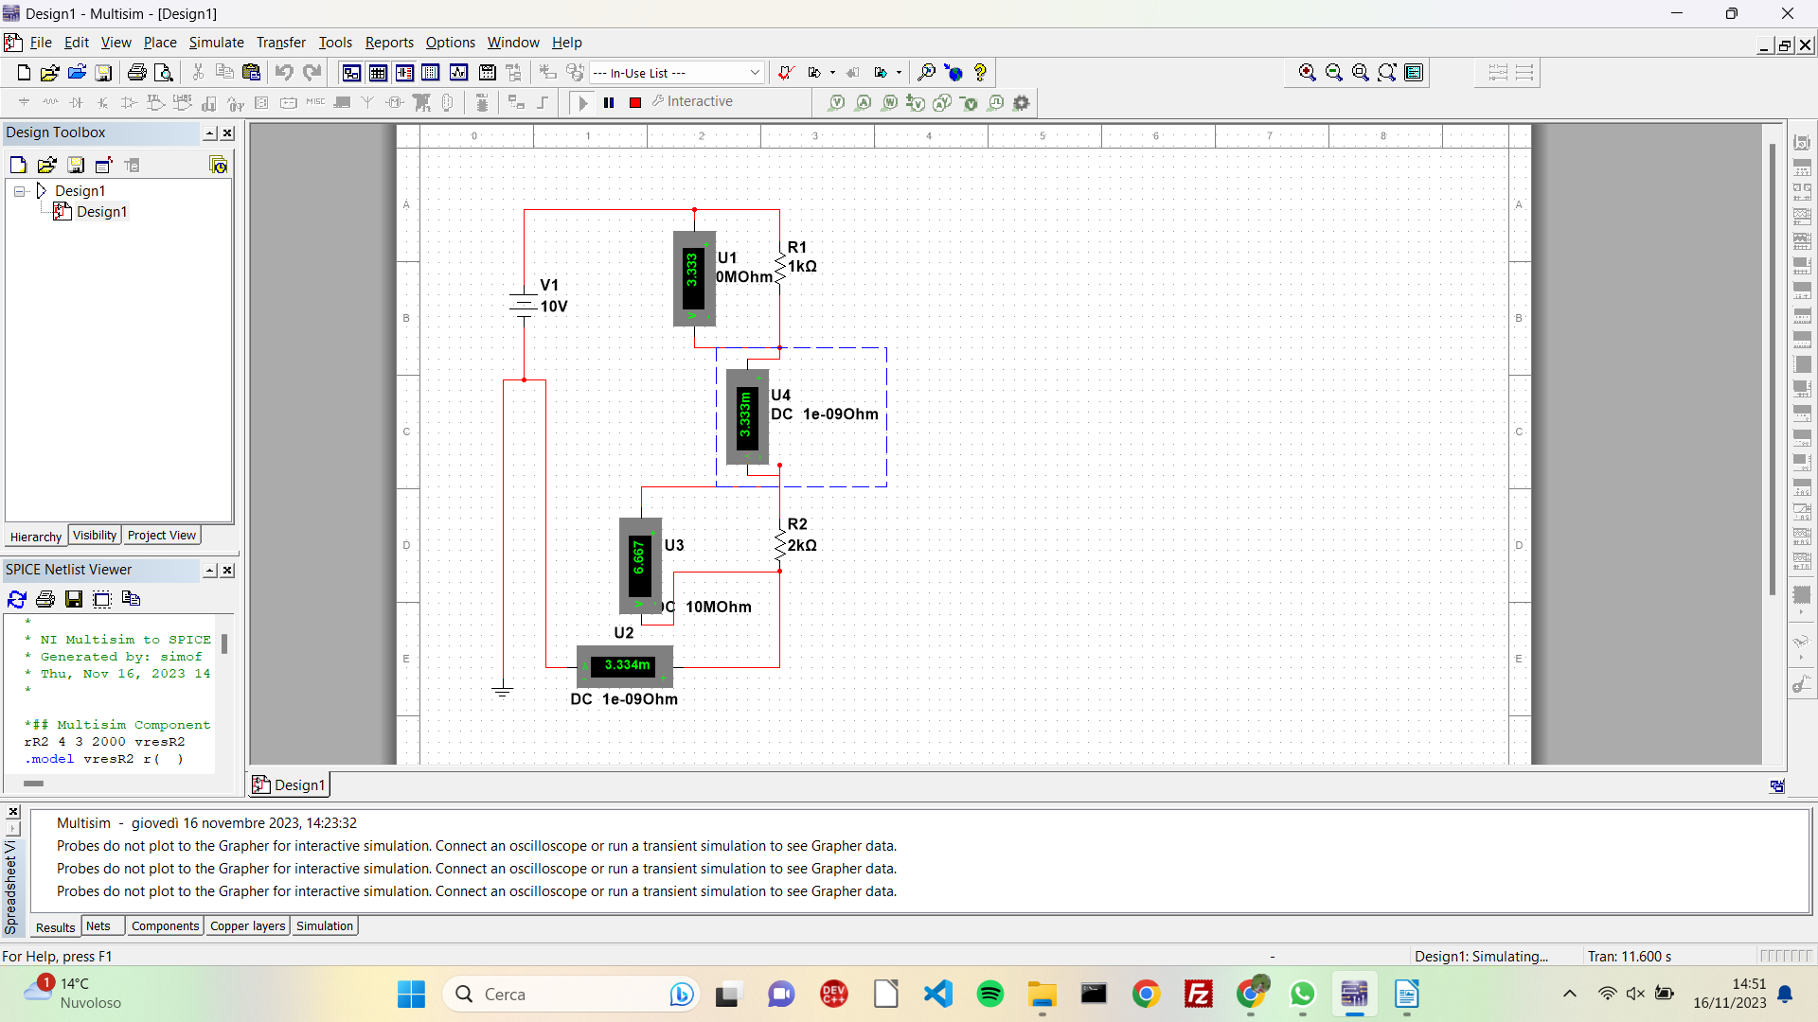

Es 3
V=10V
R1=1kΩ
R2=2kΩ
i1=i2=V/Req=10V/(1k Ω+2k Ω )=3,33mA
V1=R1*i1=1kΩ*3,33mA=3,33 V

V2=R2*i1=2kΩ*3,33mA=6,66V

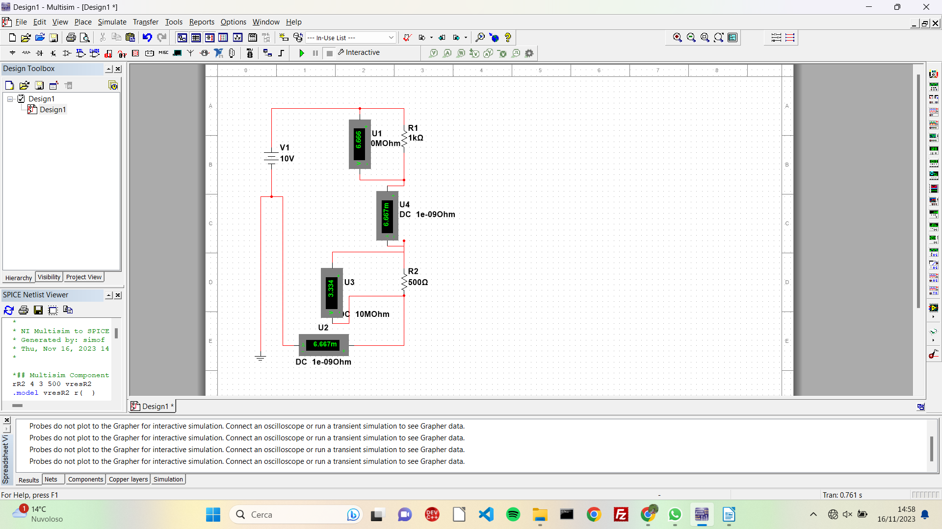
Es 4
V=10V
R1=1kΩ
R2=500Ω
i1=i2=V/Req=10V/(1kΩ+500Ω)=6,66mA
V1=i1*R1=6,66mA*1kΩ=6,66 V

V2=i2*R2=3,33mA*1kΩ=3,33V

